Name
Professor
Course
Date
Thigmomorphogenesis: The Role Of Mechanical Stimuli On Plant Growth and Development
Introduction
Mechanical stimuli plays an essential role in the determination of the growth and development rate. These stimuli affect the length and thickness of the plant stems, allowing them to thrive in different conditions. Thigmomorphogenesis can be defined as the process through which mechanical stimuli affect the growth and development of plants. Different plants have different responses to mechanical stimuli, like wind, touch by humans, animals or farm machinery. Subjecting plants to these changing stimuli affects their growth patterns, minimizing the rate of shoot elongation and stem growth, while at the same time increasing the girth of the stem. According to Coutnand and Mitchell, researchers in the last four decades have focused on understanding the process of thigmomorphogenesis, because it allows them develop effective approaches of controlling plant growth and how these changes affect the ecology. Also, the process has played a critical role in controlling the level of stress that plants are exposed to. By controlling the growth of the stem, researchers can minimize the levels of stress experienced by plants, making them more resistant and more productive. In a research conducted by Bourmaud, Gibaud, and Bailey, it was argued that the length of the shoots and stem and the diameter of the stem were depended on the number of seeds planted per m². In this research, an increase in seedlings led to a higher competition for space, implying that the plants were mechanically interacting with each other. This level of interaction affects their rate of growth. In the same research, it was evident that reducing thr concentration of the seedlings led to the development of stronger stems, which were more resistant compared to those with thin stems.
Thigmomorphogenesis is an important phenomenon in the growth of plants because it affects how plants respond to changes in light, temperature, gravity, and water. It is an important process, especially for farmers focusing on commercial agriculture and those relying on controlled agricultural environments. Previous researchers have identified that farmers have relied on the use of chemicals and fertilizers to control plant growth, flowering, and productivity. However, the need to adopt organic farming and minimize chemical use and pollution has prompted the adoption of mechanical stimulation, which has been found to induce effective plant responses like higher girth, darker leaves, strong and compact plants and delayed flowering (Frederik and Thorsten).
The aim of this lab is to portray the importance of thigmomorphogenesis in optimal plant growth and resistance to mechanical stress. This lab will focus on using beans (Phaseolus vulgaris), which is a common plant, cultivated across the world because of its high variability.
Because of changing environmental conditions, it is essential to develop plants that are resistant and able to change their structures to meet these demands. From the purpose of the study, two hypotheses were developed.
H0: Thigmomorphogenesis leads to an increase in girth, increased mechanical strength and resistance, and increased produce of beans.
H1: Thigmomorphogenesis does not affect plant growth and the level of productivity in beans.
Dependent variables - girth of plants, productivity, mechanical strength and resistance.
Independent variable - application of mechanical stimuli.
Methods
The procedure of this lab was simple and relied in easily available materials. The plants used in this case were beans, which have a short germination and maturity periods. The bean seeds used for the lab were separated into two groups, the control and treatment groups. The control group was exposed to normal growth conditions without application of mechanical stimuli. On the other hand, the treatment group was exposed to mechanical stimuli. After the seeds were obtained, they were planted into different containers, with those in the control group labelled A1 to A10 and those in the treatment group labelled from B1 to B10. Labeling the cups A and B ensured that it was easy to provide different treatments for the plants. Beans in group A were exposed in a controlled environment where the speed of wind, temperatures, water, and gravity were controlled. Controlling these conditions ensured that there was no chance of mechanical stimulation. The treatment group on the other hand was exposed to mechanical stimuli, including high speed winds, touching between the plants, and by humans. Plants in A cups were watered using drip system twice daily and plants in B cups were watered using a watering can and high pressure water two times daily. Plants in A cups were shielded from direct wind, which minimized the physical stress they were exposed to. The measures that were taken after the experiment were the height and the girth of the plants. A graph of mean change of height in the control and treatment plants was developed as well a graph showing the rates of growth of plants in A and B cups. The statistical test that was used in this lab was T-test to determine the statistical differences between plants in cups A and B.
Results
Table 1. Mean change of height of bean plants in cm over 14 days.
Plant ID | Control | Plant ID | Treatment
A-1 | 10.9 | B-1 | 4.9
A-2 | 5. 2 | B-2 | 3.4
A-3 | 1. 1 | B- 3 | 4.5
A-4 | 3.6 | B-4 | 3.2
A-5 | 5.3 | B-5 | 6.7
A-6 | 8.7 | B-6 | 8. 1
A-7 | 7. 7 | B-7 | 3.9
A-8 | 18. 7 | B-8 | 6.6
A-9 | 5.4 | B-9 | 4.0
A-10 | 5.3 | B-10 | 6.5
Standard deviation | 4.8656 | Standard deviation | 1.6752
t | 23.67 | t | 2.806
P-value | . 000 | P-value | . 000
Data from table 1 above shows that the standard deviation for the height of plants in cans A was 23.67 while in B is 1.6752. The t value in A is 23.67 while in B is 2.806. The results indicate that the height of plants in cans A is statistically significant than that of B. Plants that are not exposed to thigmomorphogenesis have a statistically higher height compared to those exposed to thigmomorphogenesis.
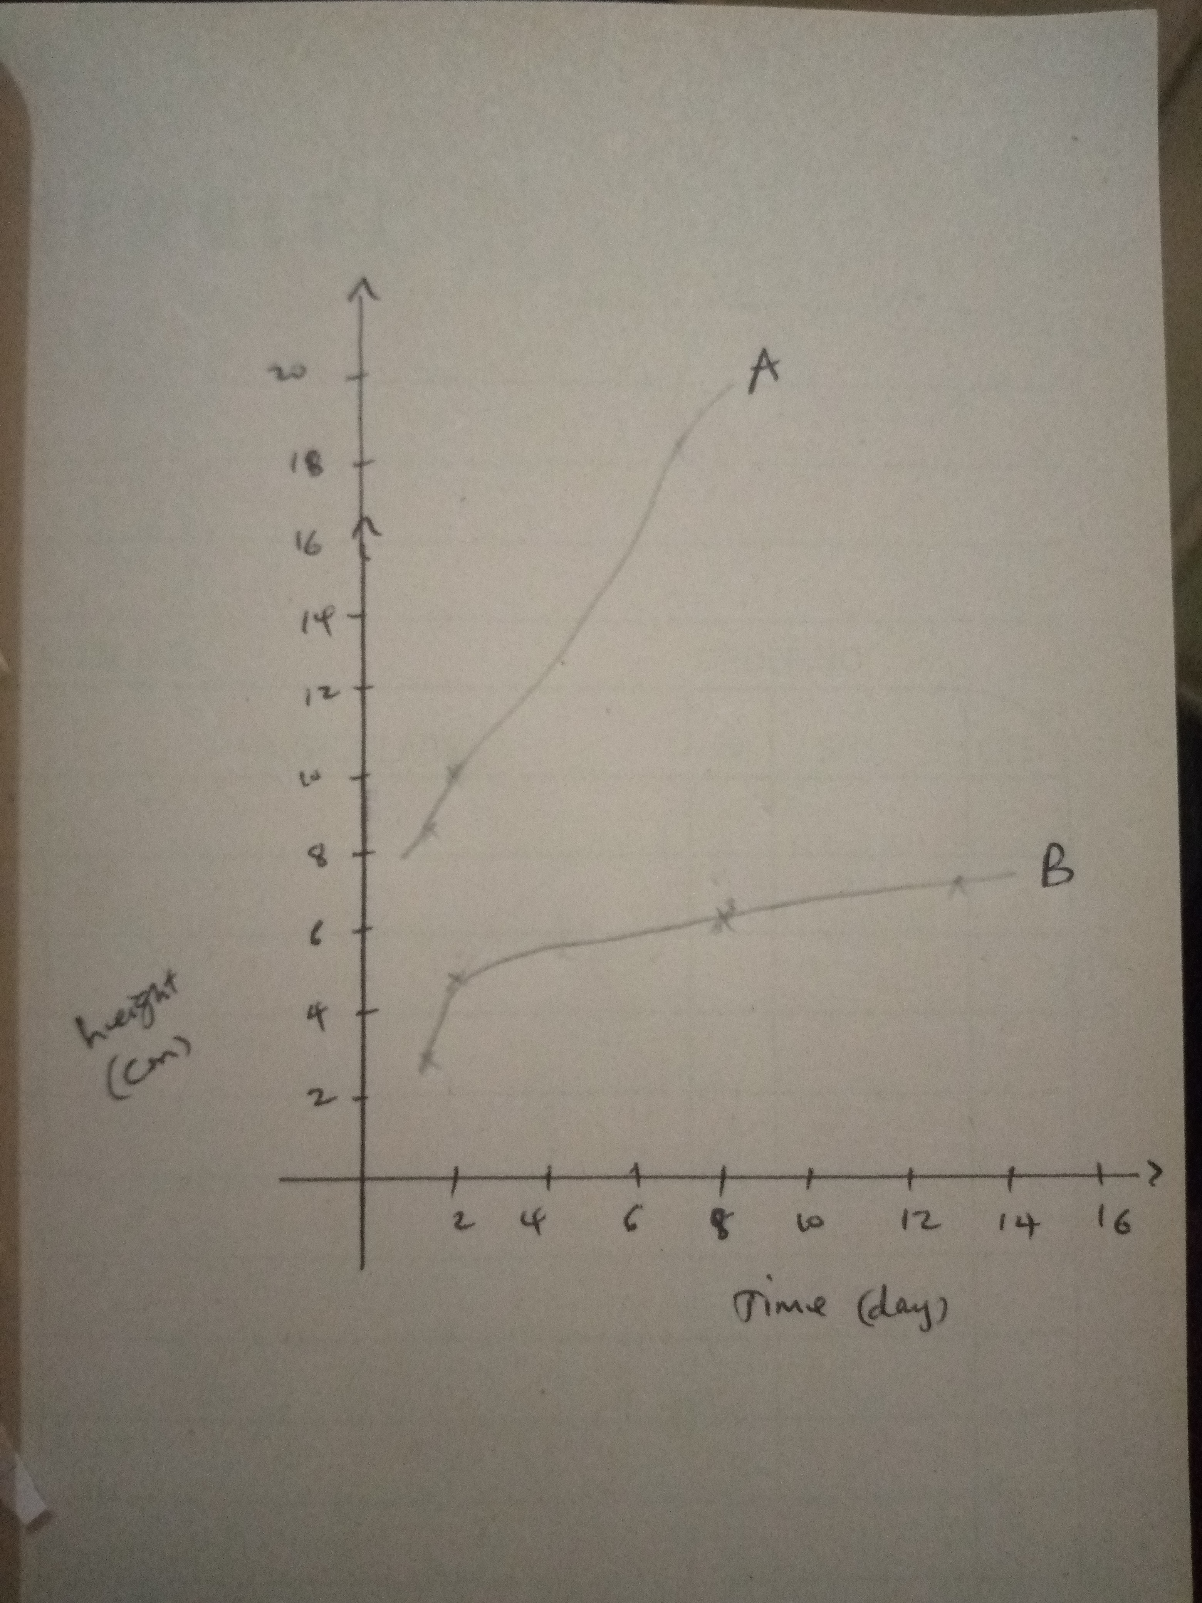
Figure 1. Graph showing the differences in mean height over time.
In figure 1, plants in cans A have a higher average height compared to plants in cans B.
Discussion
From the results in table 1 and figure 1, it can be identified that thigmomorphogenesis plays a major role in plant growth and development of their structure. In table 1, plants in cans A show a higher height because they were exposed in a controlled environment, being allows to grow without extra mechanical stimulation. On the other hand, plants in cans B were exposed to mechanical stimuli, which affected their rate of growth in height and girth. Because of mechanical stimulation that occurs when the plants are exposed to elements like wind and water and interaction with hands. Stimulating the plants in cans B leads to a change in their structure. Exposure to mechanical stimuli prompts the plants to become resistant to stress, thus improving their ability to survive and become more productive. The results are consistent with hypothesis H0. When plants are stimulated mechanically, they respond by changing their structures. These results are consistent with the findings of Bourmaud, Gibaud, and Bailey, that mechanical stimuli promotes their ability to compete and adapt to the environment.
References
Bourmaud, Alain, Gibaud Marriane, and Bailey Christophe. Impact of the seeding rate on flax stem stability and the mechanical properties of elementary fibres. Industrial Crops and Products. (2015). http://dx.doi.org/10.1016/j.indcrop.2015.10.053
Coutand C and Mitchell SJ. Editorial: Mechanical Signaling in Plants: From Perception to Consequences for Growth and Morphogenesis (Thigmomorphogenesis) and Ecological Significance. Front. Plant Sci. (2016), 7:1441. doi: 10.3389/fpls.2016.01441
Frederik Börnke, Thorsten Rocksch. Thigmomorphogenesis – Control of plant growth by mechanical stimulation, Scientia Horticulture, (2018). Volume 234, 344-353. https://doi.org/10.1016/j.scienta.2018.02.059

